**DLD LAB TASK**

**Question 01**

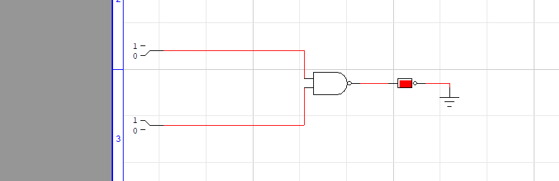

**Question 02**

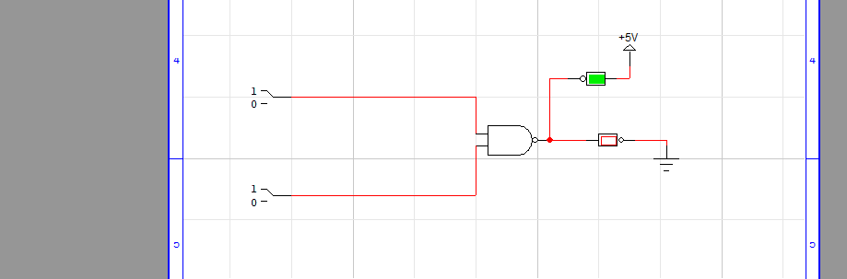

**Question 03**

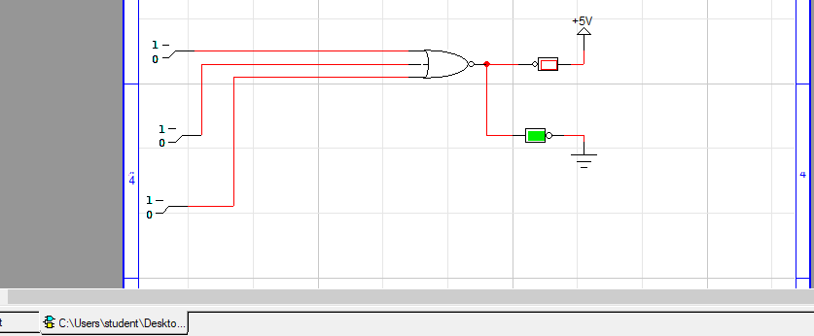

**Question 04**





**Question 05**

**A**



**B**



**Attached file of Q5 solved expression.**

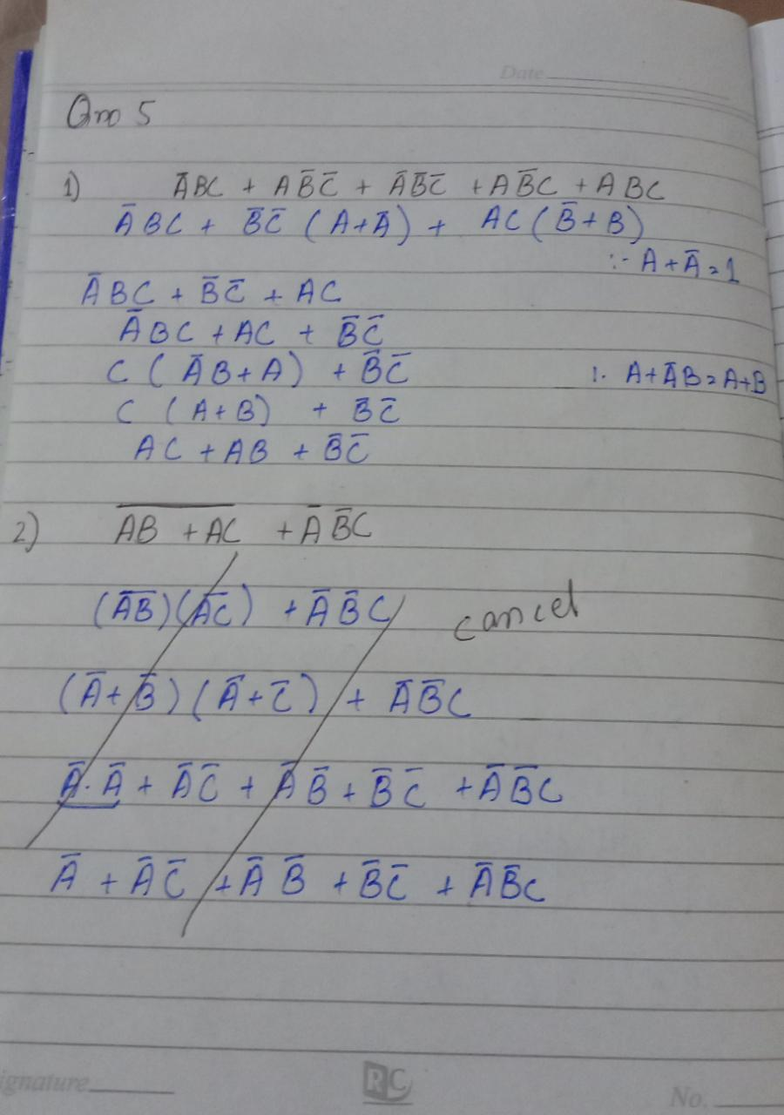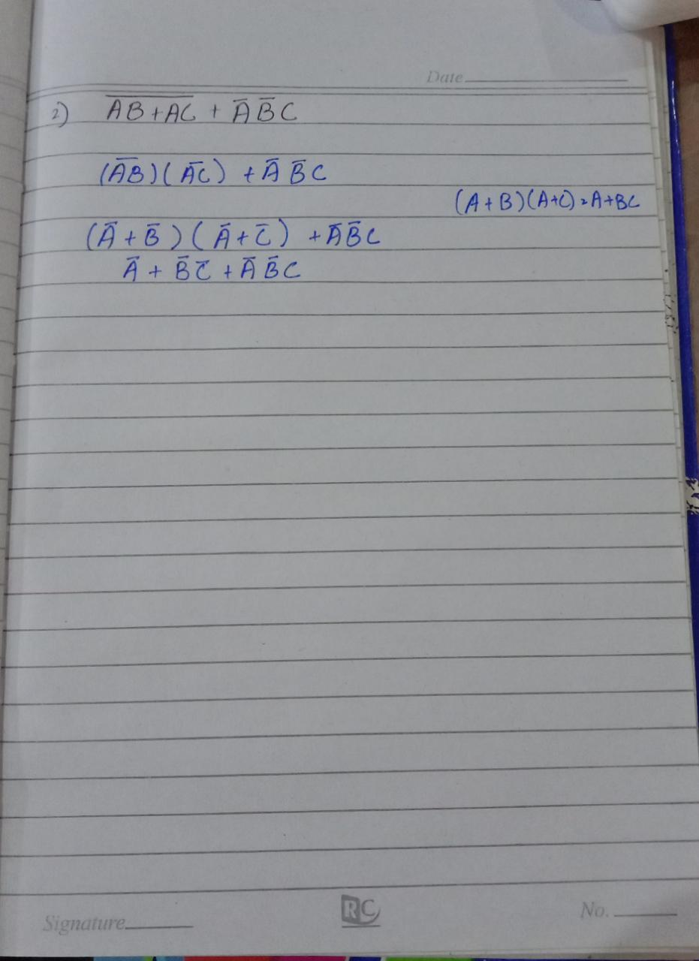

**Question 6**

**A**

**C**

**B**

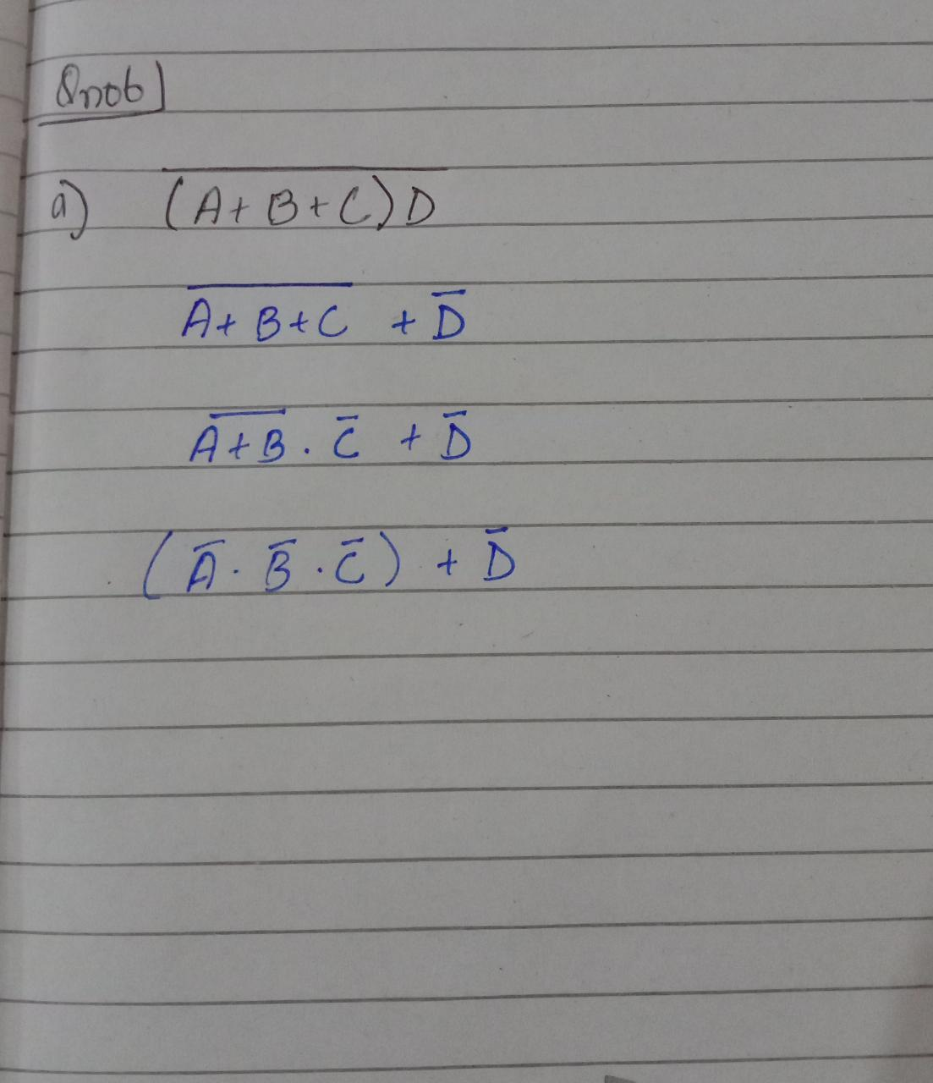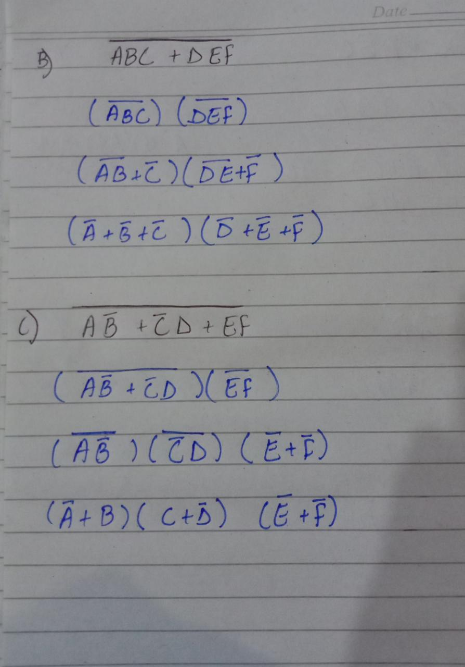

**Question 07**



**Question 08**



